
Software Engineering Department
Capstone Project Phase A

Real Estate Price Evaluation Using Machine Learning

https://github.com/Asaad164/FinalProject.git

Supervisor: Dr. Reuven Cohen
Name | Asaad Sajim | Joul Hurani
ID | 212755367 | 212873723
E-mail | Asaad.Sajim@e.braude.ac.il | Joul.Hourany@e.braude.ac.il

Table of Contents

Index | Subject | Page number
 | Abstract | 3
1 | Introduction | 3
2 | Background and Related Work | 4
2.1 | The Necessity of Estimating Real Estate Prices | 4
2.2 | Manually price estimation | 5
2.3 | Price Estimation Using Machine Learning | 6
2.4 | Existing Solutions | 6
2.5 | Research and Model Selection | 7
2.6 | Error Measures | 9
3 | Expected Achievements | 10
3.1 | Success Criteria of The Project | 11
4 | Engineering Process | 12
4.1 | Research Phase | 12
4.2 | Dataset | 13
4.3 | Implementing Random Forest in the Project | 14
4.4 | Price Prediction | 15
4.5 | Implementing the project | 17
4.6 | Product | 18
4.6.1 | Project Requirements | 18
4.6.2 | Software Architecture Diagram | 19
4.6.3 | Use Case | 20
4.6.4 | Activity Diagram | 22
4.6.5 | User Interface | 23
5 | Verification and Evaluation | 27
5.1 | Validation | 28
6 | References | 29

Abstract
This project introduces a web platform designed to estimate real estate prices in the Israeli market using machine learning. Traditional property valuation methods often depend on subjective appraisals, which can be inconsistent and time-consuming. To overcome these challenges, the platform utilizes a Random Forest algorithm, a reliable and widely used machine learning model. Random Forest works by creating multiple decision trees during the training process and combining their predictions to improve accuracy and reduce errors. Its ability to handle diverse data and highlight the importance of different property features makes it an ideal choice for this application.
The platform combines standard property features such as location, size, and number of rooms with additional user-provided details like parking availability, elevators, proximity to schools, public transport, and shopping centers. These extra details are incorporated into the prediction model, with weights assigned based on their significance to the overall property value.
The platform provides quick price estimates along with explanations of the factors influencing the valuation. By offering accurate predictions and greater transparency, this tool aims to improve the efficiency of real estate pricing for buyers, sellers, and professionals in Israel.
- Introduction
Estimating real estate prices is not an easy task because many factors influence a real estate price. These factors include the property's location, size, number of rooms, and the availability of many other features such as having parking spaces or elevators.
Traditional methods for estimating property prices often depend on the experience and opinion of the appraisers. While these methods are useful, they can sometimes be inconsistent or unfair. Appraisers may give different values for the same property because they rely on their own judgment, and the process is often slow and time-consuming. Furthermore, traditional methods struggle to handle large amounts of data, making it hard to analyze patterns and trends that can affect prices.
This project will solve these problems by creating a machine learning-based web platform. Machine learning technology can be trained on related data and make predictions. By using data from past property sales, the platform will identify patterns and relationships between property features and their prices. This method will provide a nearly accurate price estimate without relying on subjective opinions.
The platform will have a user-friendly design, allowing users to give input details about a property's features and receive an estimated price in a few seconds. Buyers will use the platform to ensure that they are paying a fair price, while sellers can make sure they are pricing their properties competitively. Real estate agents and other professionals such as appraisers will also find it useful for providing consults to their clients.
In order to build this system, we will collect and organize data from government records and other reliable sources. The data will be prepared for training the machine-learning models. The platform will be incrementally improved based on feedback and testing.
This platform will be a modern and efficient tool for estimating real estate prices. It will make the process faster, and more objective than traditional methods. This will benefit buyers, sellers, and real estate professionals by helping them make better decisions and improving trust in the real estate market.

- Background and Related Work
  - The Necessity of Estimating Real Estate Prices
Estimating real estate prices is essential, as it plays a pivotal role in the decision-making processes of various stakeholders, such as buyers, sellers, investors, and financial institutions. Here are the main reasons why estimating real estate prices is necessary:
Informed Decision-Making: Accurate property valuations help buyers and sellers to make informed decisions. Buyers need to ensure that they pay a fair price, while sellers want to ensure they receive a proper return on their investment. Real estate professionals also require accurate pricing to advise their clients effectively.

Market Efficiency: Estimating real estate prices accurately ensures that the market stays efficient. If prices are consistently over- or under-estimated, it can lead to market distortions, where properties might be underpriced or overpriced. This problem can negatively affect market stability and investor confidence [10].

Financial Decisions and Risk Assessment: Lenders, such as banks and mortgage companies, rely on property valuations to determine the loan amount that they provide to buyers. Inaccurate valuations could lead to over-lending or under-lending, creating financial risk for both lenders and borrowers [4].

Investment and Development Opportunities: For investors, knowing the accurate value of properties helps them to find profitable investment opportunities.

Taxation and Legal Compliance: Governments and local authorities require accurate property valuations to set property taxes and assess the fair distribution of tax burdens. Furthermore, proper valuation is essential in legal cases related to property disputes, inheritance, or divorce.

Transparency and Trust: Providing transparent and data-driven property valuations helps to establish trust in the real estate market. When valuations are based on verifiable data instead of personal opinions or arbitrary judgments, it fosters confidence among stakeholders and promotes a fairer, more reliable market.
  - Manually price estimation
Traditional methods of estimating real estate prices rely on manual assessments conducted by real estate professionals or appraisers. These methods are based on a combination of subjective judgment and objective factors. The process typically involves the following steps: [11]
On-Site Inspection: The appraisal process often begins with the appraiser visiting the property in person. During this inspection, the appraiser assesses the condition of the property, including its size, layout, structural integrity, and any unique features or upgrades.

Comparable Sales Analysis: One of the most common manual methods is where the value of a property is estimated by comparing it to similar properties that have recently been sold in the same area. This method involves price adjustments for differences in property features, such as size and location.
The appraiser compares the property to similar ones that have been sold recently in the same area. To ensure a reliable and accurate estimate the appraiser strives to identify properties that are as similar as possible. For example, if a building has an elevator or a parking space, or if an apartment is located on the first or the third floor, the appraiser will look for properties with similar features to ensure a fair comparison.

Documentation and Reporting: Finally, the appraiser compiles all observations and calculations into a detailed report, which serves as the official property valuation.
Despite being widely used, manual price estimation has its challenges. These methods rely on the appraiser’s knowledge and the availability of similar properties for comparison. While they provide detailed and personalized evaluations, certain drawbacks can affect their accuracy and efficiency.

figure 1: house appraisal process

Limitations of Manual Price Estimation
Time-Consuming: The appraisal process requires considerable time for inspection and research.
Subjectivity: Results can vary depending on the appraiser's experience, judgment, and interpretation of data.
Difficulty Finding Comparable Properties: It is challenging to identify properties with closely matching features, leading to less precise estimates.
While manual price estimation offers a thorough and personalized approach to evaluating real estate, it has limitations. The process is often time-intensive, relies on subjective judgment, and depends heavily on the availability of comparable properties. These challenges underline the importance of exploring alternative methods, such as Machine Learning methods, to enhance the efficiency and accuracy of real estate valuations.[2]
  - Price Estimation Using Machine Learning
The process of predicting real estate prices using machine learning begins by training a model with a data set having various property features, such as size, location, number of rooms, and additional amenities.
The model is then applied to identify patterns and relationships between these features and property prices.
Finally, the model generates a nearly accurate price estimate based on the analysis of the property features. [12]
  - Existing Solutions
Currently, there are several platforms that estimate real estate prices using machine learning. Two popular examples are the Zillow Zestimate (Rich Barton and Lloyd Frink) [8] and Idealista (Jesús Encinar) [3].
Zillow Zestimate is a well-known platform in the United States. It uses advanced algorithms to estimate property prices based on data like past sales, tax records, and user-provided details. Zillow is fast and provides accurate estimates for U.S. properties. However, it is designed only for the U.S. market and cannot handle the unique features of other countries.

figure 2: Zillow Zestimate website homepage
Idealista is a platform mainly used in Spain, Italy, and Portugal. It focuses on European real estate markets and uses data from property listings and sales to give price estimates. Idealista works well in those countries, but it is not designed for Israel or other non-European markets. The platform also gives more general price predictions and may not consider unique property features of smaller regions.

  - Research and Model Selection
To identify the most suitable machine learning model for predicting real estate prices, extensive research was conducted on various algorithms and techniques. The papers reviewed explored multiple machine learning models and their applications in real estate price prediction, highlighting their strengths and weaknesses.
Summary of Reviewed Models:
Comparing different machine learning models:
Choy and Ho (2023) [5] demonstrated the effectiveness of Extra Trees, K-Nearest Neighbors (KNN), and Random Forest (RF) models in predicting property prices using a dataset of 24,936 transactions. The article shows that the Random Forest model consistently outperformed other models in terms of error minimization and explanatory power​.
Gradient Boosting Machines (GBM):
Vargas-Calderón and Camargo (2020) trained GBM alongside the Random Forest and Support Vector Machines (SVM) model on 40,000 housing transactions. They found GBM to be marginally better than RF in terms of mean squared error (MSE), but the RF model was found to be better in its efficiency and interpretability​. [13]
Artificial Neural Networks (ANN):
Baldominos et al. (2018) compared artificial neural networks (ANN) with regression trees and support vector machines (SVM). They found that while ANN could identify complex patterns, it needed a lot of computing power, and it didn't perform consistently on smaller datasets. [1]
XGBoost:
This model was praised for its high accuracy. However, its complexity and the need for careful hyperparameter tuning made it less favorable for a scalable, web-based platform​. [13]

Key Findings from the literature review
Accuracy and Reliability: The Random Forest model demonstrated high predictive accuracy with low error rates across various datasets.
Efficiency: The RF’s model processes the structured data efficiently and its scalability makes it suitable for this project.
Feature Importance: Unlike neural networks, RF provides insights into the importance of input features, which is valuable for understanding the key drivers of property prices.
Ease of Implementation: Compared to XGBoost and ANN, RF required less computational power and was easier to tune, making it more practical for a web-based platform.
After analyzing the research, we concluded that Random Forest was the best choice for this project. Its balance of accuracy, interpretability, and scalability, make it ideal for predicting real estate prices. Moreover, its robustness to outliers and ability to handle missing data enhanced its suitability for the diverse and potentially incomplete datasets used in real estate valuation.

The Decision Tree
A decision tree is a type of algorithm that models decisions and their possible consequences in a tree-like structure. It uses a series of branching questions or conditions based on the input features to classify or predict outcomes. Each branch represents a decision, and the endpoints, known as "leaves" provide the final prediction or classification.
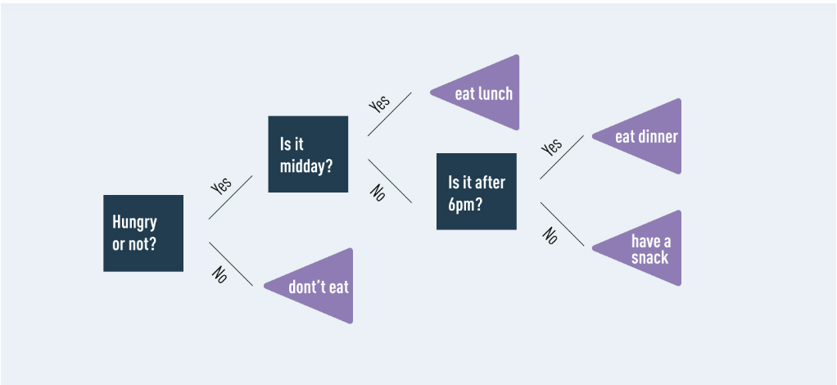
figure 3: example of a simple decision tree

The Random Forest model
Here are some properties of the random forest: [7]
Multiple Trees for Better Accuracy: Random Forest grows multiple decision trees and uses all their predictions to improve accuracy.
Voting Mechanism (Classification): In the classification task, each decision tree in the forest makes a prediction. The final classification is based on the majority of the predictions from all trees.
Averaging Predictions (Regression): Random Forest averages the predictions from all the trees to make a final prediction.
Low Correlation Between Trees: A key advantage of Random Forest is that the individual decision trees are uncorrelated. When combined, the lowest predictions are removed, and the majority of the tree's predictions guide the model toward the correct prediction.
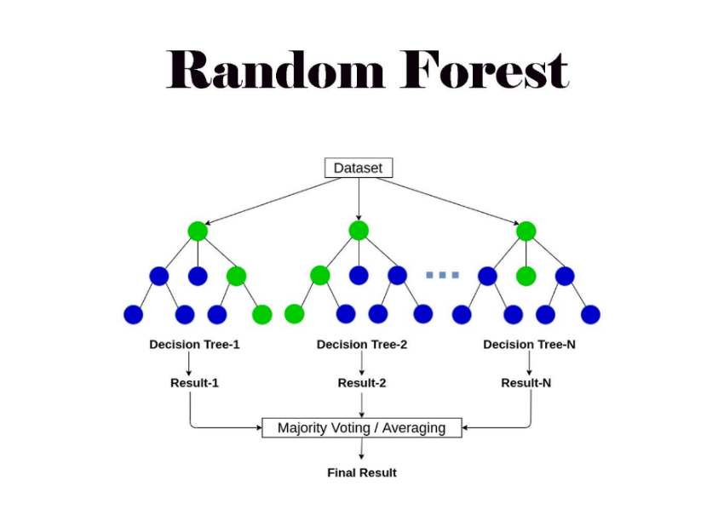
figure 4: Random Forest algorithm

  - Error Measures
Root Mean Square Error (RMSE) [15] [9]:

Root Mean Square Error (RMSE) is a frequently used metric to measure the difference between values predicted by a model or an estimator and the actual values observed. It represents the square root of the average squared differences between predicted and actual values, making it sensitive to larger errors due to the squaring step.
$$RMSE=\sqrt{\frac{1}{n}\sum_{i=1}^{n}{{(y_{i}-{\hat{y}}_{i})}^{2}}}$$
$y_{i}$: Actual values
${\hat{y}}_{i}$: Predicted values
n: Number of observations

Mean Absolute Error (MAE) [9] [14]:

The Mean Absolute Error (MAE) is a metric used to measure the average of the absolute differences between the predicted values and the actual values. It gives an idea of how far off predictions are from actual outcomes, without considering the direction of the errors (whether over or underestimations).
Mathematically, MAE is calculated as:
$$MAE=\frac{1}{n}\sum_{i=1}^{n}{\left|y_{i}-{\hat{y}}_{i}\right|}$$
$y_{i}$: Actual values
${\hat{y}}_{i}$: Predicted values
n: Number of observations

R² [6]:
The coefficient of determination, or R², is a measure that shows how good a model is at fitting the data. In regression (a type of statistical method), it tells us how well the regression line (the line the model uses) matches the real data.

${SS}_{res}=SUM{(y_{i}-{\hat{y}}_{i})}^{2}$ ${SS}_{tot}=SUM{(y_{i}-y_{avg})}^{2}$

$$R^{2}=1-\frac{{SS}_{res}}{{SS}_{tot}}$$
$y_{i}$: Actual values
${\hat{y}}_{i}$: Predicted values

- Expected Achievements
Our project is a machine learning-based web platform designed to estimate real estate prices with high accuracy. It is different from the existing websites that we mentioned earlier because it is built specifically for the Israeli market. We use local data from Israel, which makes our predictions more accurate and relevant. Our platform is designed to handle the specific challenges of Israel’s real estate market, like smaller datasets and regional differences. We also use Random Forest, which is a machine-learning algorithm that can show the property features that have the most influence on the price. This makes our platform more informative and trusted by the users.
Here are our goals for this project:
Accurate Property Price Prediction
The Random Forest algorithm will be trained on data from the Israeli real estate government recordings. The platform is expected to achieve a high level of accuracy in predicting property prices by analyzing key features such as location, size, number of rooms, and amenities.
Localization To the Israeli Market
By using datasets specific to Israel, the platform will address the unique characteristics of the local Israeli market. This includes adapting to regional pricing trends and property features that are specific to Israel, ensuring the predictions are both relevant and highly accurate.
Enhancing Market Efficiency
The project will help the real estate market by decreasing dependence on manual price estimates. The platform aims to make property valuations faster and more accessible.
User-Friendly Interface
We will develop a simple interface that allows users to input property details such as size, location, number of rooms, and features, and receive instant price predictions. The platform will explain the key factors affecting the price, so the users can know the reason behind the valuation.

  - Success Criteria of The Project
Accuracy of Price Predictions: The model should achieve at least 90% accuracy in predicting property prices, as measured by metrics such as RMSE and MAE.
It needs to have a high percentage of accuracy because even a 1% error can be a difference of thousands of shekels.
System Responsiveness: The platform will provide price predictions within seconds, to ensure a smooth and efficient user experience.
Positive User Feedback: Feedback will be collected from real estate professionals such as appraisers and other users to assess the usability and reliability of the platform.

- Engineering Process
  - Research Phase
The research phase was a strong step in building our real estate price estimation platform. We reviewed academic studies and spoke with professionals in the field to gather both theoretical and practical knowledge.
Review Of Existing Research
We looked at studies that compared machine learning models like Random Forest, Gradient Boosting Machines (GBM), and Artificial Neural Networks (ANN). These papers showed the strengths and weaknesses of each model. Based on this, we decided to use Random Forest because it is accurate, efficient, and easy to understand.

Review Of Existing Platforms
We also studied platforms like Zillow Zestimate and Idealista to learn how they work. These platforms use advanced algorithms, but they are designed for different markets.
Interview With a Real Estate Appraiser
To add practical insights, we interviewed a professional real estate appraiser. The goal was to understand how appraisers value properties and the challenges they face.
The appraiser emphasized that location is the most critical factor in determining property value, followed by the size of the property, its condition, and additional features such as parking spaces, elevators, and gardens.
He also highlighted the importance of real estate being close to schools, public transport, and shopping centers. Additionally, the appraiser noted that incomplete or missing information often requires them to rely on judgment or general market trends. When discussing what they expect from a website platform, the appraiser expressed a need for a tool that is fast and easy to use.

  - Dataset
The dataset used in this project is sourced from "Israel Tax Authority", an official Israeli government website that provides publicly available information on real estate transactions. This dataset serves as a crucial foundation for our project, as it includes comprehensive details about property sales across Israel.
Structure of the dataset
The data set includes the following information on real estate;
Number of Rooms, the Area, the Year of Built, the city, the Type (apartment, single-family home, community housing, etc..), and the Price.
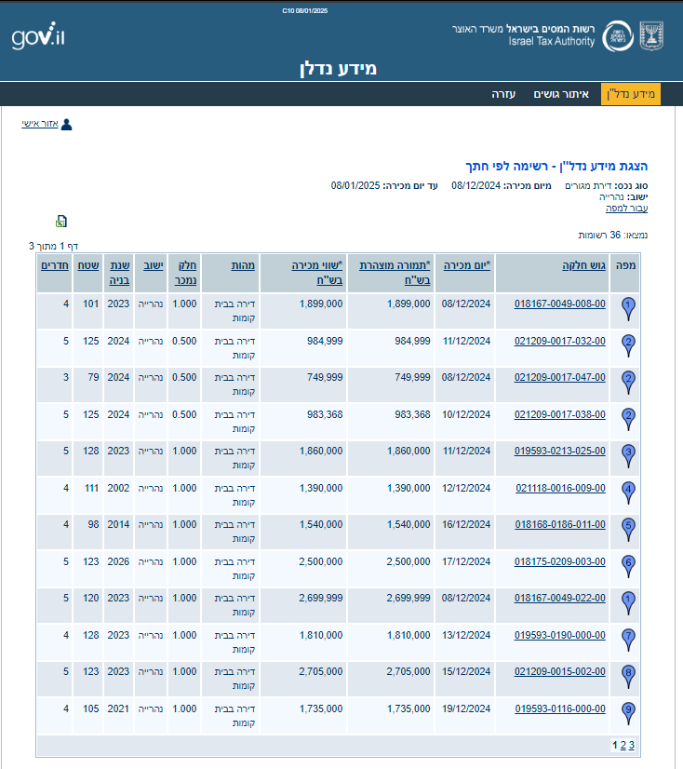
figure 5: example of the structure of the database from the "Israel Tax Authority" website

The dataset can be downloaded as an Excel file directly from the website.
Completing The Missing Data
While the dataset provides necessary details, certain features that influence property prices are not included. To address this, our project will allow users to add manually additional information about the property through the web platform.
The added data can include parking availability, elevator, view, near schools, near shopping centers, near public transport, and near parks, etc.
Integration of the missing Features in the Model
To incorporate these manually entered features into the price prediction equation, we will assign weights to each feature based on its importance.
Features with a higher impact on price will have greater weights, while less impactful features will have lower weights.
The determination of these weights will be based on professional real estate appraisers.

  - Implementing Random Forest in the Project
Why Random Forest?
Random Forest is a machine learning algorithm that will be utilized in this project to predict real estate prices. Random Forest is particularly effective for handling structured data, such as property attributes, and provides reliable predictions even in complex scenarios.
Random Forest is chosen for this project due to several key strengths:
High Accuracy: By averaging the predictions of multiple decision trees, Random Forest reduces overfitting and provides more stable and accurate results.
Robustness: It handles a wide variety of data types, including numerical and categorical variables, and is resistant to noise and missing values.
Feature Importance: Random Forest ranks the importance of input features, helping to identify which property characteristics (e.g., size, location, amenities) have the most significant impact on pricing.
Scalability: The algorithm can process large datasets efficiently, making it suitable for analyzing extensive real estate records.

To implement Random Forest in this project, we need to take the following steps:
Data Collection:
Existing real estate transaction data will be gathered from government records and other reliable sources.
The dataset will include features such as property size, location, number of rooms, and year built.
Data Preprocessing:
The collected data will be cleaned by removing duplicates and by handling missing values. Categorical variables, such as property type or location, will be encoded for use in the model.
Model Training:
The dataset will be split into training and testing subsets, typically in 80% training, and 20% testing.
The training subset will be used to build and optimize the Random Forest model. Hyperparameters such as the number of trees, maximum depth, and the minimum number of samples per split will be fine-tuned to achieve the best performance.
Model Evaluation:
The testing subset will be used to evaluate the model’s accuracy. Metrics such as Root Mean Square Error (RMSE), Mean Absolute Error (MAE), and R² will be used to assess the model’s performance.
Expected Outcomes:
By using Random Forest, this project will produce a system capable of accurately estimating real estate prices based on structured data. The model will provide clear and consistent results, helping buyers, sellers, and appraisers make informed decisions.
The project will ensure that the Random Forest model is developed, tested, and deployed effectively, creating a user-friendly platform for real estate price estimation.

  - Price Prediction
The price prediction in our project is done using a Random Forest model. To enhance the accuracy and flexibility of the predictions, the model incorporates both core features from the dataset and additional user-provided features. These additional features are weighted based on their influence on the final property price estimation.
The prediction equation is defined as follows:
$$y=\frac{1}{N}\sum_{i=1}^{N}{T_{i}\left(x_{base}\right)}*(w_{tree}+\sum_{j=1}^{M}{w_{{add}_{j}}*x_{{add}_{j}}})$$
Where:
y: The predicted property price
$w_{tree}$: The weight of the diction tree's price-output.
N: The number of decision trees in the random forest.
$T_{i}$: The prediction from the i-th decision tree.
$M$: The number of additional features.
$w_{{add}_{j}}$: The Weight assigned to the j-th additional feature,
reflecting his relative importance
$x_{{add}_{j}}$: Binary value of the j-th additional feature provided by the user.
(1 = exist, 0 = doesn’t exist)

Explanation of the equation
$$\frac{1}{N}\sum_{i=1}^{N}{T_{i}\left(x_{base}\right)}*w_{tree}$$
This part calculates the predicted price contribution based on the core property features, such as size, location, and number of rooms. It uses the combined outputs of the decision trees to represent the main prediction for the property.

$$\sum_{j=1}^{M}{w_{{add}_{j}}*x_{{add}_{j}}}$$
This part adds the influence of additional features provided by the user, like parking availability, elevator, and proximity to schools, or shopping centers.
Determining the Weights
We will take a sample of houses that a professional appraiser recently evaluated. These houses will be used as a reference to adjust the weights in our formula.
For each house, we will use the baseline features as input to the Random Forest model to get its predicted price. The weight assigned to the Random Forest output ($w_{tree}$) will be the highest since it forms the main part of the prediction.
After that, we will assign initial weights to the additional features and calculate the final predicted price using the formula. We will then compare this predicted price to the actual price given by the appraiser.
If the predicted price is not close enough to the appraiser’s price, we will adjust the weights for the additional features and repeat the process. This process will be done for the houses until the predictions are as accurate as possible.

Normalization
the sum of the weights ($w_{tree}$, $w_{{add}_{j}}$) must equal 1 to maintain balance in the prediction formula. This ensures that each component contributes proportionally to the final price estimation.

Why This Equation Works
Includes User-Added Features:
The equation allows additional features (like proximity to schools or building conditions) that the user enters to be part of the prediction.
These features add more information that can improve the accuracy of the price estimate.
Handles Missing Features:
If the user does not provide some additional information, the model sets the importance (weight) of those features to zero.
This way, missing information does not cause errors in the prediction.
Keeps the Random Forest System:
The Random Forest model works by combining predictions from many decision trees.
This equation still uses that system but adds adjustments for user inputs.
Balances Feature Importance:
More important features have higher weights, so they influence the price more.
Less important features have smaller weights and affect the price less.
  - implementing the project
The implementation of this project will follow a structured approach to ensure the development of a functional and user-friendly web platform for real estate price estimation.
Tools and Technologies
Backend: Python with Flask to handle server-side logic and integrate the Random Forest model.
Frontend: HTML, CSS, and JavaScript to build an interactive and responsive user interface.
Machine Learning: Scikit-learn library to train and deploy the Random Forest model.
Data Preparation
The dataset will be downloaded from the "Israel Tax Authority" as an Excel file.
It will be cleaned to prepare it for training the machine learning model.
Model Development
A Random Forest regression model will be trained using Scikit-learn on the prepared dataset.
The trained model will be saved and integrated into the backend for real-time predictions.

Website Development
The frontend will include a form to get the property details such as size, location, and additional features.
The backend will use the trained model to predict the property prices.
Deployment
The platform will be deployed on a cloud-based service and will be accessible on the web.

  - Product
    - Project Requirements
Functional Requirements
1. | The system will allow users to input property details such as size, location, number of rooms, and amenities.
2. | The system will allow providing an estimated price based on the entered property details.
3. | The system will allow displaying error messages if required property details are missing or incorrectly entered.
4. | The system will allow users to download the valuation results as a file.
5. | The system will allow users to view the factors that influenced the price estimate in an easy-to-understand format.

Non-Functional Requirements
1. | the platform will be used by buyers, sellers, and real estate professionals.
2. | The platform will be a web-based application with accessibility from any device with internet connectivity.
3. | Users will get an estimated price based on the entered property details.
4. | The system will achieve an accuracy of at least 90% in property valuation predictions.
5. | The system will process price predictions in under 4 seconds.
6. | Users can view the factors that influenced the price estimate.
7. | the factors that influenced the price estimate are written in an easy-to-understand format

    - Software Architecture Diagram
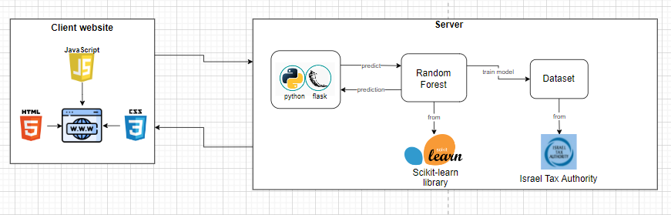
figure 6: Software Architecture Diagram
This diagram shows the main parts of the software system of the real estate price estimation platform. The system has three main parts: the Frontend, the Backend, and the Machine Learning Model which is included in the Backend.
Client Website:
- The client website is developed using HTML, CSS, and JavaScript, which are standard tools for creating dynamic and responsive user interfaces.
- It serves as an interface where users can input property details such as size, location, and additional features.
- After submission, it sends the input data to the server and displays the predicted property price.

Server:
- The server component is implemented using Python with Flask, a lightweight web framework.
- It processes incoming requests from the client website and forwards the data to the machine learning model (Random Forest) for predictions.
- After receiving predictions from the model, the server formats the response and sends it back to the client's website.
Machine Learning Model:
- The Random Forest model is used to predict property prices.
- It receives the processed input from the server, runs the prediction algorithm, and returns the estimated property price to the backend.

Dataset:
- The dataset used is the "Israel Tax Authority".
- It is used to train the Random Forest model during the development phase.

    - Use Case
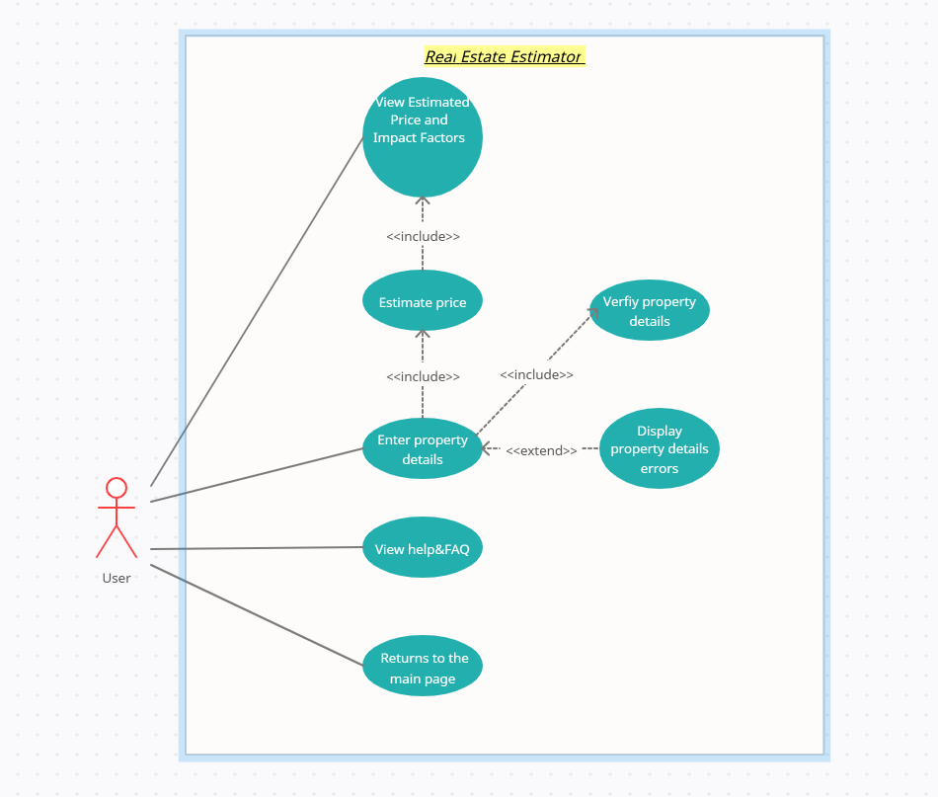
figure 7: Use Case diagram
The diagram shows a Use Case diagram, which is a simple picture of what a system can do from a user's point of view. It explains how the system and its users interact with each other.
The use cases are as follows:
Enter Property Details:
The user provides property information such as size, location, number of rooms, etc. to begin the estimation process.
Verify Property Details:
The system validates the entered property details for completeness and correctness.
Display Property Details Errors:
If any input is invalid or missing, the system displays error messages to guide the user in correcting them.
Estimate Price:
The system uses machine learning algorithms to predict the property value based on the entered details.
View Estimated Price and Impact Factors:
The user can see the predicted price and the impact factors.
View Help & FAQ:
The user can access to FAQ Section (Common questions and answers), How-to Guide (Instructions for using the platform), and Support Contact (Email address for additional help).
Return to Main Page:
The user can navigate back to the main page.

    - Activity Diagram

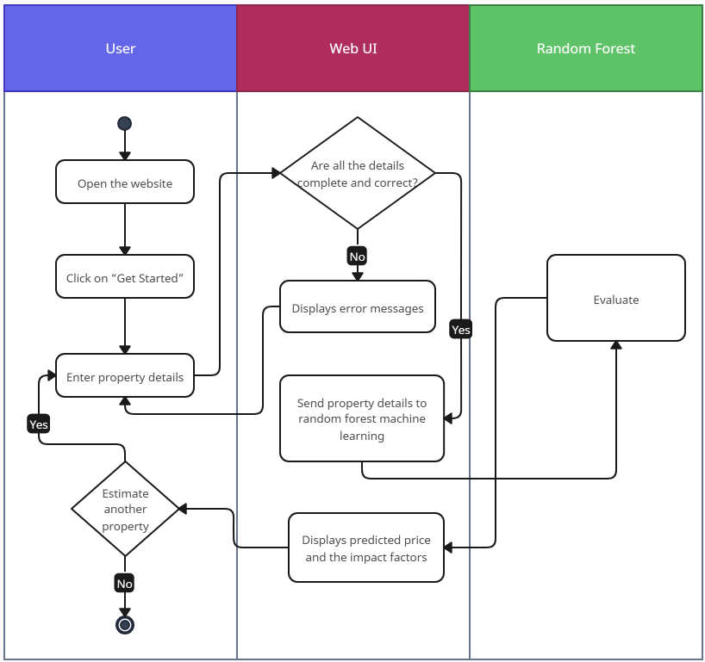
figure 8: activity diagram

The activity diagram below illustrates the process of property price estimation in our system. The user begins by opening the website and clicking on the "Get Started" button. This action leads them to enter the necessary property details. The Web UI then validates the details to ensure they are complete and correct.
If the details are incomplete or incorrect, the system displays error messages, prompting the user to make corrections.
If the details are accurate, the Web UI forwards the property information to the backend, where the random forest machine learning model processes the input data.
The random forest model evaluates the details and predicts the property's price. The result is displayed to the user through the Web UI. Finally, the user can choose to estimate another property or exit the system.

    - User Interface
Home Page

figure 9: home page for the website
Description Text - Brief explanation of the platform's purpose, helping users understand they can get property price estimates.
Get Started Button - A prominent blue button that takes users directly to the estimation form.
Navigation Bar - Located at the top of the page with the following buttons:
Home - Returns to the main page.
Estimate - Takes users to the property estimation form.
Help - Opens the FAQ and support section.

Estimate Page (Property Form)
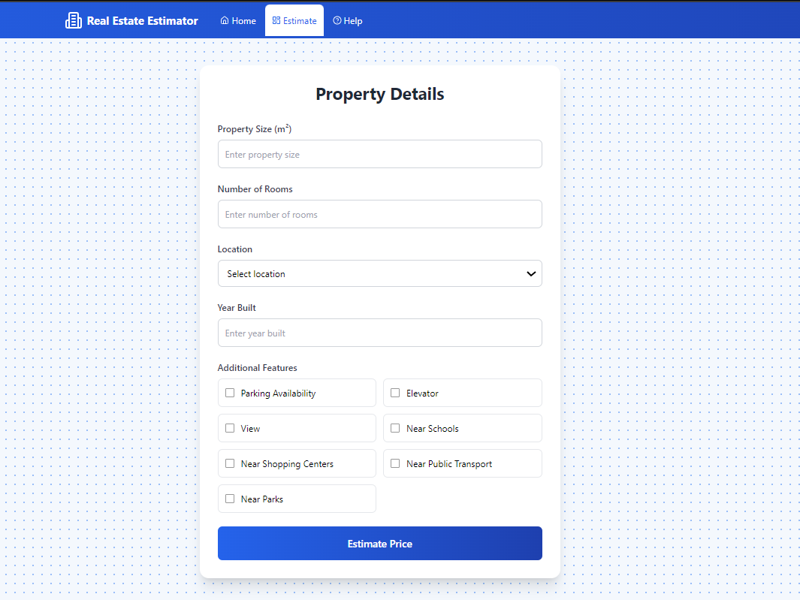
figure 10: Estimate page for the website
Property Details Form with these input fields:
Property Size Entry - Where users enter the size in square meters.
Room Counter - This is for inputting the number of rooms.
Location Selector - Dropdown menu with city options
Year Built Field - Where users enter the construction year.
Parking Available- Checkbox
Elevator- Checkbox
View- Checkbox
Near Schools- Checkbox
Near Shopping Centers- Checkbox
Near Public Transport- Checkbox
Near Parks- Checkbox
Estimate Button - A large blue button at the bottom that generates the price estimate.

Results Page
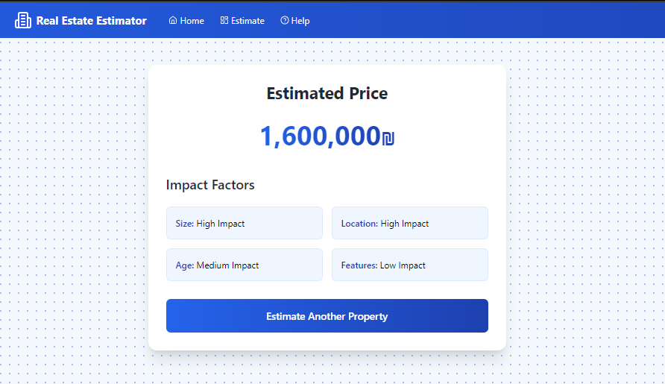
figure 11: Results page for the website

After submitting the form, users see:
Estimated Price - Displayed prominently in large text.
Impact Factors showing how different features affected the price:
Size Impact
Location Impact
Age Impact
Features Impact
New Estimate Button - Allows users to start a new estimation.

Help Page
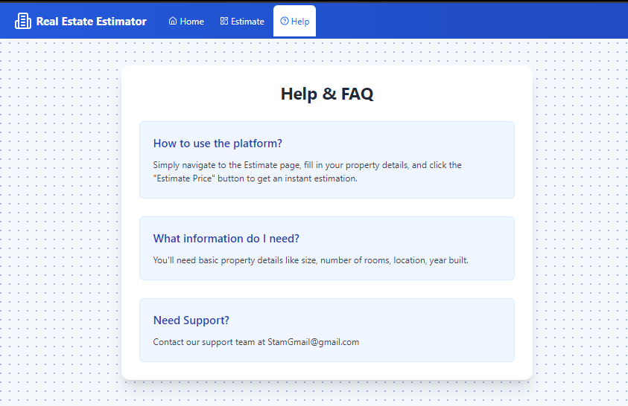
figure 12: Help page for the website
FAQ Section - Common questions and answers
How-to Guide - Instructions for using the platform.
Support Contact - Email address for additional help.

- Verification and Evaluation

This table outlines a set of test cases created to assess the functionality of our program. The testing framework selected is the "Unit test" module, which is an integral part of the Python standard library.

Case | Test Case | Expected Result
1 | Press "Get Started". | The user is taken to the next page (Estimate page).
2 | Entering the necessary property details correctly and completely and Press” Estimate Price”. | The system accepts the details and proceeds to estimate the property price, the result (price + impact factors) is displayed to the user.
3 | Entering the necessary property details not correctly or not completely and Press” Estimate Price”. | Error is shown:  “The property details you entered are incomplete or incorrect. Please review the information and try again. ”
4 | Press "Estimate another property" | The user is taken to the Estimate page to start a new estimation.
5 | Access Help & FAQ | The system redirects the user to the Help & FAQ section.
6 | Return to the main page | The system redirects the user to the home page.
7 | No result output in the final step | Error is shown:  “An error occurred while evaluating the property details. Please try again.”

  - Validation

Front-End: We will validate that the user interface functions smoothly across various platforms, including desktop computers, tablets, and smartphones. This validation will involve testing on a diverse range of devices with different screen sizes to ensure responsiveness and consistency.

Model: We will validate the machine learning model by ensuring it performs accurately and reliably in predicting real estate prices. This will involve testing the model using a separate testing dataset (80% training, 20% testing) to evaluate its performance metrics, such as accuracy, Root Mean Square Error (RMSE), $R^{2}$, and Mean Absolute Error (MAE). Furthermore, the model’s predictions will be reviewed by an appraiser to ensure they align with realistic property values.

User Experience: We will gather feedback on the user experience by having both appraisers and non-appraisers try the platform. This will help us know how easy the system is to use for different types of users.
We will collect their opinions on the platform’s functionality, design, and usability, as well as identify any features or improvements that could enhance their experience. The feedback will guide us in making necessary adjustments to ensure the platform is user-friendly and meets the needs of all users.

- References

[1] Alejandro Baldominos, Iván Blanco, Antonio José Moreno, Rubén Iturrarte, Óscar Bernárdez and Carlos Afonso. (21 November 2018). "Identifying Real Estate Opportunities Using Machine Learning". Appl. Sci. 2018, 8, 2321; doi:10.3390/app8112321.
[2] Blake L. (2021). Common challenges in real estate appraisal. Vocal Media. https://vocal.media/families/common-challenges-in-real-estate-appraisal
[3] Jesús Encinar. Idealista. https://www.idealista.com
[4] Li Cain, S. (2024, November 11). Home appraisal vs. home inspection: What’s the difference? Bankrate. https://www.bankrate.com/real-estate/home-appraisal-vs-inspection/
[5] Lennon H. T. Choy & Winky K. O. Ho. (25 March 2023). "The use of machine learning in real estate research". Land 2023, 12, 740. https://doi.org/10.3390/land12040740.
[6] Newcastle University. Coefficient of determination (R-squared). Maths Resources https://www.ncl.ac.uk/webtemplate/ask-assets/external/maths-resources/statistics/regression-and-correlation/coefficient-of-determination-r-squared.html
[7] Rachel Meltzer. (31 August 2023). What Is Random Forest?. Careerfoundry. https://careerfoundry.com/en/blog/data-analytics/what-is-random-forest/#what-is-random-forest
[8] Rich Barton & Lloyd Frink. Zillow Zestimate. https://www.zillow.com/how-much-is-my-home-worth/
[9] Root mean squared error versus mean absolute error. (2018, July 1). https://jmlb.github.io/flashcards/2018/07/01/mae_vs_rmse/
[10] The Investopedia Team. (2022). Market efficiency. Investopedia. Reviewed by M. J. Boyle. Fact-checked by J. Ma. https://www.investopedia.com/terms/m/marketefficiency.asp
[11] Tina Hay. Appraisal: Understanding property valuation methods. Napkin Finance. https://napkinfinance.com/napkin/appraisal/
[12] Varun Tyagi. (2024, February 28). House price prediction with machine learning. Medium.
https://medium.com/@varun.tyagi83/house-price-prediction-with-machine-learning-d49f93d681f2
[13] Vladimir Vargas-Calderon & Jorge E. Camargo. (17 December 2020). Towards robust and speculation-reduction real estate pricing models based on a data-driven strategy. arXiv:2012.09115v1 [econ.GN] 26 Nov 2020.
[14] Wikipedia. (21 December 2024). Mean absolute error. https://en.wikipedia.org/wiki/Mean_absolute_error
[15] Wikipedia contributors. Root mean square deviation. Wikipedia. https://en.wikipedia.org/wiki/Root_mean_square_deviation

